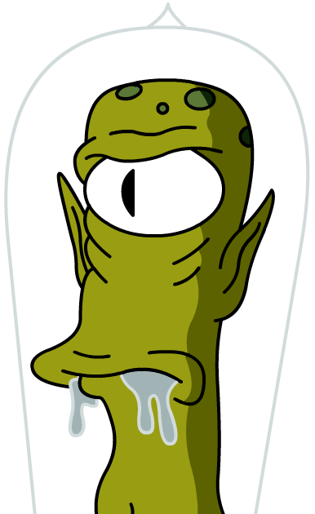
Alien Abduction Vignette
By Lindsey Meckley, Jennifer L. Hillemann, and Donniell Cooke

Introduction
You have been abducted by aliens! Their species is in danger of extinction because their asexual reproduction strategy does not allow for genetic diversity or adaptation to their otherwise evolving planet. They have superior telekinetic powers, and can direct their cells and cell structures to do whatever they want, but so far their attempts have resulted in disaster: cells with exponentially increasing numbers of chromosomes, or cells with too many of some, and not enough of other chromosomes, etc. Sadly, these beings have focused all their studies in Physics (which is how they are able to get to us!), but have shamefully neglected their Biology studies.
They need you to teach them how to combine cells from two different individuals so that they can create novel genetic combinations, genetic variation, and ultimately, adaptability of the species. You have been chosen because of your Biology-enthused, and enabled attitudes, as well as your superior skills in visual representation as artists.
Their survival depends on your help!

Task
To create a demonstration product or model that can visually explain Mitosis (what their cells do now), Meiosis (what they need to teach certain cells to do) and why Meiosis is necessary for their survival.
Some project ideas include:
- poster with movable components
- children’s book
- flipbook (either hand-drawn or created with digital pictures)
- short movie
Sadly, these aliens also neglected their linguistics studies as well, so you will need to make sure you represent all the important information in your visual model, so the aliens understand. You’ll want to be as clear as possible, so make sure cell structures can be distinguished from one another and easily identified.
Since we don’t want these mysterious beings to retaliate (death rays?) if our plans are inaccurate or unclear, we will carefully assess each product against a thorough rubric before beaming them up to the Mother Ship.
May the force be with you!

Process
(1) Form Groups
You will first need to split up into groups of 2-3 students. You will work with this group for the duration of your project.
(2) Brainstorm
Together with your group, you will brainstorm ideas for your mitosis/meiosis presentation to this alien group. Please remember that their species is in danger of extinction because their asexual reproduction strategy does not allow for genetic diversity or adaptation to their otherwise evolving planet. They need you to teach them how to combine cells from two different individuals so that they can create novel genetic combinations, genetic variation, and ultimately, adaptability of the species.
(3) Research
You will need to collect the information you will want to include in your presentation to this alien group. You will find a number of helpful links listed under resources.
(4) Build Project
As a group, you will create a demonstration product or model that can visually explain Mitosis (what their cells do now) and Meiosis (what they need to teach certain cells to do).
Some project ideas include:
- posters with movable components
- children’s books
- flipbooks (either hand-drawn or created with digital pictures
- short movies
Please keep in mind that you will need to make sure you represent all the important information in your visual model, so the aliens understand.
Resources
You may use your textbook and other classroom resources to research your project information. Below you will find a number of links that will also assist you in beginning your research.

Basic Genetics Websites
The following is a list of websites that will be useful in researching basic information on human genetics.
- Tour of the Basics
- Kids Genetics

Mitosis Websites
The following is a list of websites that will be useful in researching mitosis.
- Mitosis Animation
- The Cell Cycle & Mitosis Tutorial
- Mitosis in an Animal Cell Animation
- Interactive Mitosis Tutorial

Meiosis Websites
The following is a list of websites that will be useful in researching meiosis.
- Meiosis Animation
- Meiosis Tutorial
- Meiosis in an Animal Cell Animation
- Meiosis Video

Evaluation
Below is a link to the rubric that your teacher will use to assess your work. Your group should review the rubric to get a better idea of what is expected from you. You will also use this rubric to evaluate your peers.
Rubric
You may also use the following checklist to evaluate your own project:
- All stages/phases are included
- Consistent representation of key cell structures for entire model
- Checklist of important features
- Demonstrates an understanding of when and why mitosis and meiosis occur
- Able to discuss models’ effectiveness with peers constructively, using scientific language

Conclusion
You group will be given 3-5 minutes to present your project to the class. You will earn a composite grade that includes your teacher's evaluation as well as your peer evaluations.
Throughout this project, you should gain a better understanding of the cell cycle, particularly mitosis and meiosis, as well as gain experience in group work and speaking about the cell cycle using scientific language.
Good luck!

